Assignment No:9

Name : Rutuja Chaudhari
Class : CSAI-B (Batch 2)
Roll No : 26

Title: Design and develop a website using REACT, NodeJS and MySql.

Problem Statement: Design and develop a responsive website for an online book store using REACT, Node JS/ PHP and MySQL/ MongoDB/Oracle having 1) Home Page2) Login Page 3) Catalogue Page: 4) Registration Page: (database)

Course Objective: To learn REST API based enterprise website development using REACT, Node JS, Spring Boot with different database technologies.

Course Outcome: Write Web API/RESTful API application programming interface to communicate with Springboot as a server side technology.

Tools Required: VSCode, MySql, Firefox/GoogleChrome

Theory:
1. Introduction to Node JS
1.1 What is Node.js?
- Node.js is an open-source, cross-platform, JavaScript runtime environment that allows developers to run JavaScript code outside of a web browser.
- It is built on Google Chrome’s V8 JavaScript Engine.
- Node.js is primarily used for building fast, scalable, and server-side applications.

1.2 Key Features of NodeJS
- Server-Side JavaScript: NodeJS allows JavaScript to run outside the browser, enabling backend development.
- Asynchronous & Non-Blocking: Uses an event-driven architecture to handle multiple requests without waiting, improving performance.
- Single-Threaded Event Loop: Efficiently manages concurrent tasks using a single thread, avoiding thread overhead.
- V8 Chrome Engine: High performance, Open-Source Javascript web assembly engine developed by google and rewoned for compiling JS into native machine code to execute it with exceptional speed.
- Scalable & Lightweight: Ideal for building microservices and handling high-traffic applications efficiently.
- Rich NPM Ecosystem: Access to thousands of open-source libraries through Node Package Manager (NPM) for faster development.

1.3 Components of the Node.js Architecture
- Requests: Depending on the actions that a user needs to perform, the requests to the server can be either blocking (complex) or non-blocking (simple).
- Node.js Server: The Node.js server accepts user requests, processes them, and returns results to the users.
- Event Queue: The main use of Event Queue is to store the incoming client requests and pass them sequentially to the Event Loop.
- Thread Pool: The Thread pool in a Node.js server contains the threads that are available for performing operations required to process requests.
- Event Loop: Event Loop receives requests from the Event Queue and sends out the responses to the clients.
- External Resources: In order to handle blocking client requests, external resources are used. They can be of any type ( computation, storage, etc).
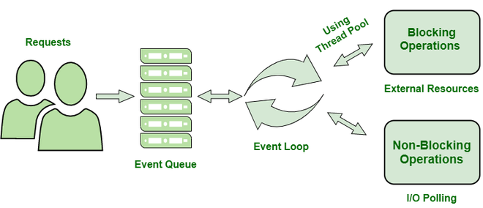
- Users send requests (blocking or non-blocking) to the server for performing operations.
- The requests enter the Event Queue first at the server-side.
- The Event queue passes the requests sequentially to the event loop. The event loop checks the nature of the request (blocking or non-blocking).
- Event Loop processes the non-blocking requests which do not require external resources and returns the responses to the corresponding clients
- For blocking requests, a single thread is assigned to the process for completing the task by using external resources.
- After the completion of the operation, the request is redirected to the Event Loop which delivers the response back to the client

1.4 Advantages of Node.js
- High performance and scalability.
- Suitable for real-time applications (e.g., chat apps, streaming apps).
- Large ecosystem with npm.
- Easy to learn for JavaScript developers.
1.5 Applications of Node.js
- Real-time web applications (Chat, Gaming).
- RESTful APIs and backend services.
- Streaming and data-intensive applications.
- IoT and Microservices-based systems.
1.6 Limitations of Node.js
- Not suitable for CPU-intensive tasks.
- Callback hell (complex nested callbacks).
- Single-threaded nature may limit performance for heavy computation.

2. Installation on Windows
Step 1: Download Node.js
- Visit the official Node.js website: https://nodejs.org
- You’ll see two versions:
  - LTS (Long Term Support): Stable version (recommended)
  - Current: Latest features (for developers who need cutting-edge features)
Choose LTS version and download the .msi installer for Windows.
Step 2: Run the Installer
- Open the downloaded .msi file.
- Follow the setup wizard:
  - Accept the License Agreement.
  - Choose installation folder (default is fine).
  - Check the box “Add to PATH” (important for running Node from Command Prompt).
- Click Install and wait for completion.
Step 3: Verify Installation
Open Command Prompt (CMD) or PowerShell and type:
node -v This will show your Node.js version.
npm -v This will show your npm version.

3. Node.js Core Modules List
Module Name | Description / Purpose | Commonly Used Methods / Functions
fs (File System) | Used to handle file operations like read, write, update, delete, etc. | fs.readFile(), fs.writeFile(), fs.appendFile(), fs.unlink()
http | Used to create HTTP servers and clients. | http.createServer(), http.request(), http.get()
https | Used to create secure HTTP (SSL/TLS) servers. | https.createServer()
os (Operating System) | Provides information about the operating system. | os.platform(), os.type(), os.freemem(), os.totalmem()
path | Used for handling and transforming file paths. | path.join(), path.resolve(), path.basename(), path.extname()
url | Provides utilities for URL resolution and parsing. | url.parse(), url.format()
querystring | Helps parse and format URL query strings. | querystring.parse(), querystring.stringify()
events | Allows working with custom events using EventEmitter. | on(), emit(), once()
stream | Used to handle streaming data like reading/writing large files or video/audio streams. | stream.Readable, stream.Writable, stream.pipe()
buffer | Used for handling binary data directly. | Buffer.alloc(), Buffer.from(), Buffer.concat()
crypto | Provides cryptographic functionalities such as hashing, encryption, and decryption. | crypto.createHash(), crypto.createCipheriv()
net | Creates TCP servers and clients for network applications. | net.createServer(), net.connect()
dns | Used to perform DNS lookup and name resolution. | dns.lookup(), dns.resolve(), dns.reverse()
child_process | Enables running other system processes from Node.js. | exec(), spawn(), fork()
readline | Allows reading input from command line one line at a time. | readline.createInterface()
timers | Provides functions for scheduling execution. | setTimeout(), setInterval(), setImmediate()
assert | Used for testing expressions, helps in unit testing. | assert.equal(), assert.strictEqual(), assert.deepEqual()
zlib | Used to compress or decompress files using Gzip/Deflate. | zlib.gzip(), zlib.unzip()
tty | Provides classes for handling text terminals (used in CLI apps). | tty.isatty()
v8 | Provides access to V8 engine statistics and features. | v8.getHeapStatistics()
util | Contains utility functions for debugging and formatting. | util.format(), util.promisify(), util.inspect()
cluster | Enables load balancing by running multiple Node.js processes. | cluster.fork(), cluster.isMaster
repl | Provides a Read-Eval-Print Loop for interactive programming. | repl.start()
perf_hooks | Used to measure performance and latency in Node.js apps. | performance.now()
inspector | Provides debugging and profiling tools for Node.js. | inspector.open(), inspector.close()

4. Node Package Manager (NPM)
- NPM stands for Node Package Manager.
- It is the default package manager for Node.js, automatically installed when Node.js is installed.
- NPM helps install, manage, update, and remove packages (modules) that add functionality to Node.js applications.
- It also allows developers to share and reuse code efficiently.

4.1 Key Functions of NPM
Function | Description
Package Installation | Download and install libraries or modules for Node.js.
Dependency Management | Keeps track of all installed packages and their versions in package.json.
Version Control | Allows installing specific versions of packages.
Global & Local Installation | Install packages globally (available system-wide) or locally (specific project).
Publishing Packages | Developers can publish their own packages to the NPM registry.

4.2 NPM Directory Structure
- Every Node.js project can have a node_modules/ folder containing all installed packages.
- The package.json file keeps track of the dependencies and project metadata.
myapp/
├── node_modules/
├── package.json
└── app.js

4.3 Important NPM Commands
Command | Description | Example
npm -v | Check NPM version | npm -v
npm init | Initialize a new Node.js project and create package.json file | npm init
npm init -y | Quickly create package.json with default values | npm init -y
npm install <package> | Install a package locally in project | npm install express
npm install -g <package> | Install package globally | npm install -g nodemon
npm uninstall <package> | Uninstall a package | npm uninstall express
npm update <package> | Update an installed package | npm update express
npm list | List installed packages | npm list
npm outdated | Show outdated packages | npm outdated
npm run <script> | Run a script defined in package.json | npm run start
npm publish | Publish a package to npm registry | npm publish

4.4 package.json File
It is the heart of any Node.js project — stores information about the project and its dependencies.
{
"name": "myapp",
"version": "1.0.0",
"description": "My first Node.js project",
"main": "app.js",
"scripts": {
"start": "node app.js"
},
"dependencies": {
"express": "^4.18.2",
"mongoose": "^7.0.3"
}
}

Key Fields:
Field | Description
name | Name of your project/package
version | Version number
description | Short description of project
main | Entry point file (usually app.js or index.js)
scripts | Commands that can be run using npm run
dependencies | List of required modules for the project
devDependencies | Modules required only during development
author | Developer’s name
license | License type (MIT, ISC, etc.)

Commonly Used NPM Packages
Package Name | Purpose
express | Web framework for building REST APIs
mongoose | MongoDB object modeling tool
nodemon | Automatically restarts app when files change
cors | Enable Cross-Origin Resource Sharing
dotenv | Load environment variables from .env file
body-parser | Parse incoming request bodies
jsonwebtoken | Implement authentication using JWT
bcryptjs | Encrypt passwords
multer | Handle file uploads
axios | Make HTTP requests
chalk | Add colors in terminal output

Conclusion: Hence, we have Successfully designed a responsive website for an online book store using REACT, Node JS and MySQL.

Source Code:
MySQL Setup
CREATE DATABASE bookstore;
USE bookstore;
CREATE TABLE users (id INT AUTO_INCREMENT PRIMARY KEY, name VARCHAR(255), email VARCHAR(255) UNIQUE, password VARCHAR(255));

CREATE TABLE books (id INT AUTO_INCREMENT PRIMARY KEY, title VARCHAR(255), author VARCHAR(255), price DECIMAL(10,2));
INSERT INTO books (title, author, price) VALUES('The Alchemist', 'Paulo Coelho', 10.99),
('1984', 'George Orwell', 8.99),('Rich Dad Poor Dad', 'Robert Kiyosaki', 12.50);

Backend Setup

Step 1: Create Project Folders in VSCode [frontend and backend]
Step 2: Initialize Node.js project
cd bookstore
mkdir backend
cd backend
npm init -y
Step 3: Install dependencies
npm install express mysql2 cors body-parser bcryptjs jsonwebtoken dotenv
Step 4: Create Controllers and routes folder
Step 5: Create db.js, .env, authController.js, bookController.js, auth.js, books.js files
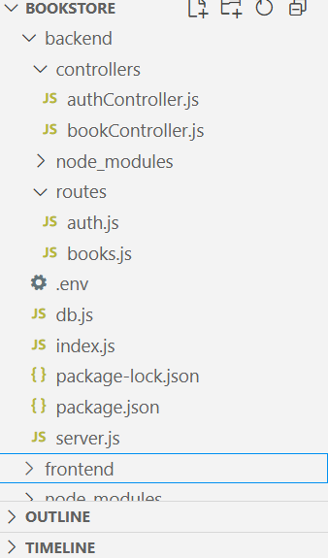
Backend Folder structure

Database Connection [db.js]
// Path: backend/db.js
const mysql = require('mysql2');
const dotenv = require('dotenv');
dotenv.config();

const db = mysql.createConnection({
host: process.env.DB_HOST,
user: process.env.DB_USER,
port : 3309,
password: process.env.DB_PASSWORD,
database: process.env.DB_NAME
});

db.connect((err) => {
if (err) throw err;
console.log('MySQL Connected...');
});
module.exports = db;
.env
// Path: backend/.env
DB_HOST=localhost
DB_USER=root
DB_PASSWORD=root
DB_NAME=bookstore
JWT_SECRET=mySuperSecretKey123!
Main server file: index.js
// Path: backend/index.js
const express = require('express');
const cors = require('cors');
const bodyParser = require('body-parser');

const authRoutes = require('./routes/auth');
const bookRoutes = require('./routes/books');

const app = express();
app.use(cors());
app.use(bodyParser.json());

app.use('/api/auth', authRoutes);
app.use('/api/books', bookRoutes);

const PORT = 5000;
app.listen(PORT, () => console.log(`Server running on port ${PORT}`));

Auth Routes: auth.js
// Path: backend/routes/auth.js
const express = require('express');
const db = require('../db');
const bcrypt = require('bcryptjs');
const jwt = require('jsonwebtoken');
const dotenv = require('dotenv');

dotenv.config();
const router = express.Router();

// REGISTER ROUTE
router.post('/register', (req, res) => {
const { name, email, password } = req.body;
const hashedPassword = bcrypt.hashSync(password, 8);

db.query(
'INSERT INTO users (name, email, password) VALUES (?, ?, ?)',
[name, email, hashedPassword],
(err, result) => {
if (err) {
console.error('Database error:', err);
return res.status(500).send({ error: 'Database error' });
}
res.status(201).send({ message: 'User registered successfully' });
}
);
});

// LOGIN ROUTE
router.post('/login', (req, res) => {
const { email, password } = req.body;

db.query('SELECT * FROM users WHERE email = ?', [email], (err, results) => {
if (err) return res.status(500).send({ error: 'Database error' });

if (results.length === 0)
return res.status(404).send({ message: 'User not found' });

const user = results[0];
const isPasswordValid = bcrypt.compareSync(password, user.password);

if (!isPasswordValid)
return res.status(401).send({ message: 'Invalid password' });

const token = jwt.sign({ id: user.id }, process.env.JWT_SECRET, { expiresIn: '1h' });

res.send({
token,
user: { id: user.id, name: user.name, email: user.email },
});
});
});

module.exports = router;
Book Routes: books.js
// Path: backend/routes/books.js
const express = require('express');
const router = express.Router();
const db = require('../db');
const { getBooks } = require('../controllers/bookController');

router.get('/', (req, res) => {
db.query('SELECT * FROM books', (err, results) => {
if (err) return res.status(500).send({ error: 'Database error' });
res.send(results);
});
});
module.exports = router;
Book Controller: bookController.js
// Path: backend/ controllers/bookController.js
const db = require('../db');

const getBooks = (req, res) => {
db.query('SELECT * FROM books', (err, results) => {
if (err) return res.status(500).send(err);
res.send(results);
});
};
module.exports = { getBooks };
Auth Controller: authController.js
// Path: backend/ controllers/ authController.js
const express = require('express');
const db = require('../db');
const bcrypt = require('bcryptjs');
const jwt = require('jsonwebtoken');
const dotenv = require('dotenv');

dotenv.config();
const router = express.Router();
router.post('/register', (req, res) => {
const { name, email, password } = req.body;
const hashedPassword = bcrypt.hashSync(password, 8);

// Insert user into database
db.query(
'INSERT INTO users (name, email, password) VALUES (?, ?, ?)',
[name, email, hashedPassword],
(err, result) => {
if (err) {
console.error('Database error:', err);
return res.status(500).send({ error: 'Database error' });
}
res.status(201).send({ message: 'User registered successfully' });
}
);
});

router.post('/login', (req, res) => {
const { email, password } = req.body;

db.query('SELECT * FROM users WHERE email = ?', [email], (err, results) => {
if (err) {
console.error('Database error:', err);
return res.status(500).send({ error: 'Database error' });
}

if (results.length === 0) {
return res.status(404).send({ message: 'User not found' });
}

const user = results[0];
const isPasswordValid = bcrypt.compareSync(password, user.password);

if (!isPasswordValid) {
return res.status(401).send({ message: 'Invalid password' });
}

// Generate JWT token
const token = jwt.sign({ id: user.id }, process.env.JWT_SECRET, { expiresIn: '1h' });

res.send({
token,
user: { id: user.id, name: user.name, email: user.email },
});
});
});
module.exports = router;
Server.js

const express = require('express');
const cors = require('cors');
const app = express();

app.use(cors());
app.use(express.json());

const authRoutes = require('./routes/auth');
const bookRoutes = require('./routes/books');

app.use('/api/auth', authRoutes);
app.use('/api/books', bookRoutes);

app.listen(5000, () => console.log('Server running on http://localhost:5000'));

Frontend Setup
Step 1: Create React App
cd bookstore
npx create-react-app frontend
cd frontend
npm install axios react-router-dom
Step 2: Create component folder and Catlog.js,Login.js,Navbar.js, Register.js file
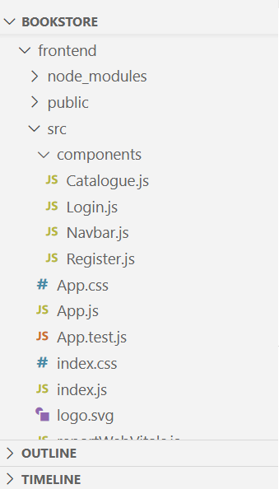
Frontend Folder Structure

App.js
import React from "react";
import { BrowserRouter as Router, Routes, Route } from "react-router-dom";
import Login from "./components/Login";
import Catalogue from "./components/Catalogue";

function App() {
return (
<Router>
<div>
<h1 style={{ textAlign: "center" }}>Online Book Store</h1>
<Routes>
{/* Home page: show Register and Login */}
<Route
path="/"
element={
<div>
<Login />
</div>
}
/>

{/* Catalogue page */}
<Route path="/catalogue" element={<Catalogue />} />
</Routes>
</div>
</Router>
);
}

export default App;
Navbar.js
import React from 'react';
import { Link } from 'react-router-dom';

const Navbar = () => (
<nav>
<Link to="/">Home</Link> |
<Link to="/catalogue">Catalogue</Link> |
<Link to="/login">Login</Link> |
<Link to="/register">Register</Link>
</nav>
);

export default Navbar;

Login.js
import React, { useState } from "react";
import axios from "axios";
import { useNavigate } from "react-router-dom";
import Register from "./Register";

function Login() {
const [showRegister, setShowRegister] = useState(false);
const [user, setUser] = useState({ email: "", password: "" });
const [message, setMessage] = useState("");
const navigate = useNavigate();

const handleChange = (e) => {
setUser({ ...user, [e.target.name]: e.target.value });
};

const handleSubmit = async (e) => {
e.preventDefault();
try {
const res = await axios.post("http://localhost:5000/api/auth/login", user);
localStorage.setItem("token", res.data.token);
setMessage("Login successful!");
navigate("/catalogue");
} catch (err) {
setMessage("Login failed: " + (err.response?.data?.message || "Server error"));
}
};

const handleRegisterClick = () => {
setShowRegister(true);
};

if (showRegister) {
return <Register />;
}

return (
<div style={styles.container}>
<h2>Login</h2>
<form onSubmit={handleSubmit} style={styles.form}>
<input type="email" name="email" placeholder="Email" onChange={handleChange} required />
<input type="password" name="password" placeholder="Password" onChange={handleChange} required />
<button type="submit">Login</button>
<button type="button" onClick={handleRegisterClick}>Register</button>
</form>
<p>{message}</p>
</div>
);
}

const styles = {
container: { textAlign: "center", padding: "20px" },
form: { display: "flex", flexDirection: "column", alignItems: "center", gap: "10px", width: "250px", margin: "auto" }
};

export default Login;
Register.js
import React, { useState } from "react";
import axios from "axios";

function Register() {
const [user, setUser] = useState({ name: "", email: "", password: "" });
const [message, setMessage] = useState("");

const handleChange = (e) => {
setUser({ ...user, [e.target.name]: e.target.value });
};

const handleSubmit = async (e) => {
e.preventDefault();
try {
const res = await axios.post("http://localhost:5000/api/auth/register", user);
setMessage(res.data.message || "Registration successful!");
} catch (err) {
setMessage("Registration failed: " + (err.response?.data?.message || "Server error"));
}
};

return (
<div style={styles.container}>
<h2>Register</h2>
<form onSubmit={handleSubmit} style={styles.form}>
<input type="text" name="name" placeholder="Name" onChange={handleChange} required />
<input type="email" name="email" placeholder="Email" onChange={handleChange} required />
<input type="password" name="password" placeholder="Password" onChange={handleChange} required />
<button type="submit">Register</button>
</form>
<p>{message}</p>
</div>
);
}

const styles = {
container: { textAlign: "center", padding: "20px" },
form: { display: "flex", flexDirection: "column", alignItems: "center", gap: "10px", width: "250px", margin: "auto" }
};

export default Register;
Catalogue.js
import React, { useEffect, useState } from "react";
import axios from "axios";

function Catalogue() {
const [books, setBooks] = useState([]);
const [loading, setLoading] = useState(true);

useEffect(() => {
// Fetch all books from backend
const fetchBooks = async () => {
try {
const res = await axios.get("http://localhost:5000/api/books");
setBooks(res.data);
} catch (err) {
console.error("Error fetching books:", err);
} finally {
setLoading(false);
}
};

fetchBooks();
}, []);

if (loading) return <p style={{ textAlign: "center" }}>Loading books...</p>;

return (
<div style={{ textAlign: "center" }}>
<h2>Book Catalogue</h2>
{books.length === 0 ? (
<p>No books available</p>
) : (
<div style={{ display: "flex", flexWrap: "wrap", justifyContent: "center", gap: "20px" }}>
{books.map((book) => (
<div
key={book.id} // assuming your books table has 'id'
style={{
border: "1px solid #ccc",
padding: "10px",
width: "200px",
borderRadius: "5px",
}}
>
<h3>{book.title}</h3>
<p>Author: {book.author}</p>
<p>Price: ${book.price}</p>
</div>
))}
</div>
)}
</div>
);
}

export default Catalogue;
Execution:
Start Backend
C:\VSCode\ReactJS\bookstore>cd backend
C:\VSCode\ReactJS\bookstore\backend> node server.js

Start FrontEnd
C:\VSCode\ReactJS\bookstore> cd frontend
C:\VSCode\ReactJS\bookstore\frontend> npm start
Output

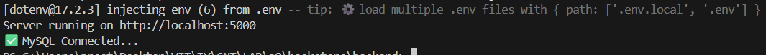

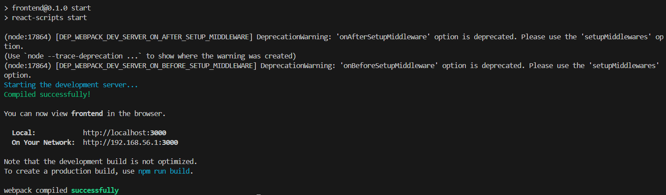

Register Page
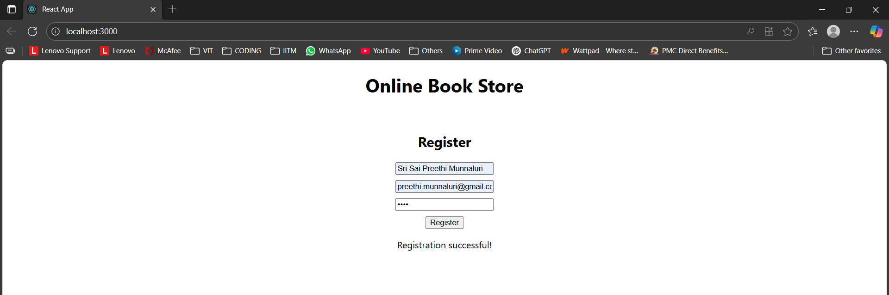
rutujachaudhari32@gm
Rutuja Chaudhari

Login Page
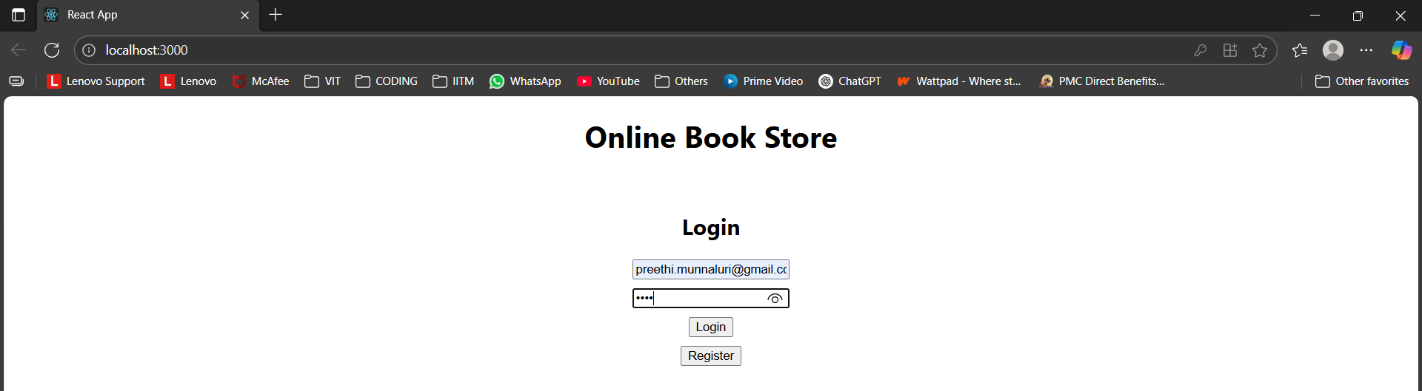

Catalogue Page
